14 Masking in Color Panel
Find the Power window tab, select square
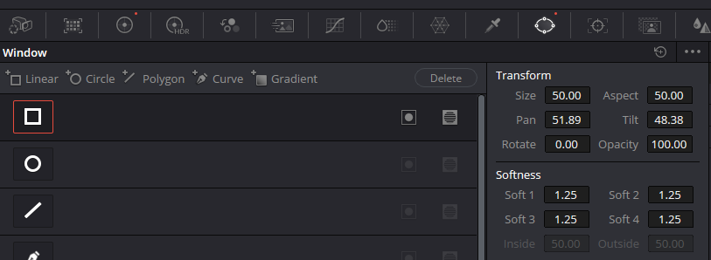

Fit it
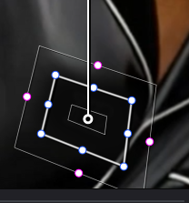
You will want to move these color wheels, to match or cover up something that needs to be covered. In our instance, we wanted to remove a logo, and turn the logo to match the color of the shirt. If this is a problem, you can also add a patch of color in a clip on the timeline above this clip. And use that to cover up the trade mark.
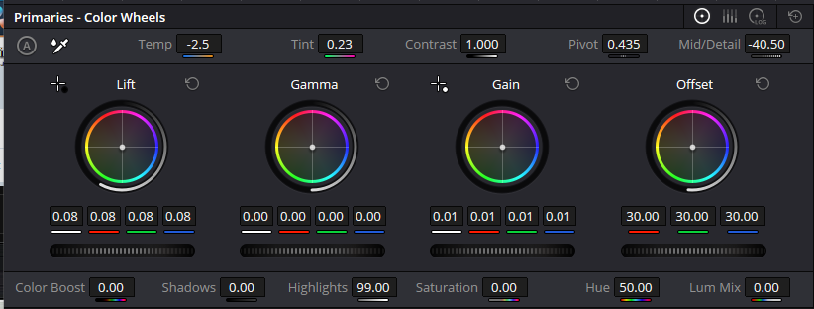

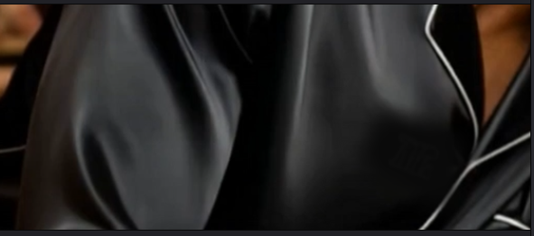

Tracker
The color panel has its own tracker. As the movie plays, it should track and move with the area that you have targeted with the Power window.
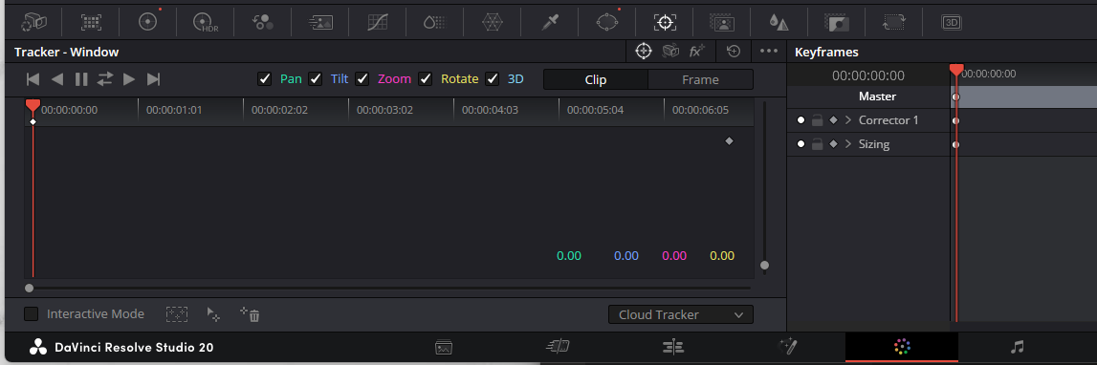
Hit the Track Forward button at the top of this window.
